**Artificial Intelligence Landing Page**

**—----------------------------------------------------------------**

1. **Introduction:**

Animation/Video - 3D

Welcome to Wappnet Systems – Pioneering AI Solutions for Information Technology

Heading + 2 or 3 line content + add call to action button

1. **Overview of Wappnet.AI: () - No Heading**

Unveiling the Future: Understanding Artificial Intelligence with us

1. **Evolution of AI(Birth till now using interactive charts)**

Unlocking Innovation: Key Features of Our AI Solutions

1. **Why your Business Requires AI (Product)**

AI Advantage: Transforming Industries with us

Customer Success Stories(Our Products with Industry Pointed)

CTA Button

Display one or 2 of the product which can be accessed here immediately for fixed attempts per visit (To be Confirmed)

1. **Services:**

Tailored Solutions: Explore Our Range of AI Services

For eg, generative AI

SmartAI Assistants n chatbots

AI Product development

Recommendation Engines

AI securities

Tableau

PowerBi

Data analysis & collection using AI

LLMs

**Note: 1st section ( AI / ML consultations and services related) 2nd sections (related to analytics) 3rd section (Data sets)**

1. **Our Artificial Intelligence Development Process**
2. **Our Engagement Models**
3. **AI Models We Have Expertise In / Why Choose Us + Get a Quote**
4. **Testimonials:**

What Our Clients Say About Us

1. **Demo/Free Trial: TBD/TBC**

Hands-On Experience: Request a Demo or Start Your Free AI Trial

1. **FAQs:**

Got Questions? Here Are Answers to Common AI Inquiries

1. **Contact Information:**

Connect with Us: Reach Out for Expert AI Guidance

1. **Blog/Updates:**

Stay Informed: Explore the Latest in AI on Our Blog

**Suggestions(TBD) :**

1. Website with miracles i.e movement of features, animations, colour play
2. Auto play of some animations/actions with time stamp fixed for it
3. Voice over Command(Multi - Lingual) throughout the website
4. Any feature listings/Services/Products must contain 3D Images/Videos and animated icons/buttons.
5. Interesting Walk through over voice with possibilities of selection
6. Mega menu to be selected for website
7. AI Courses - Self Developed Courses for selling on the website (Educational Purposes)
8. In portal Social Media Integration display(Like SBDC)
9. AI Community Forum
10. Language Selection
11. Mode Selection

**Menu Inclusions :**

Home

Products

Services

About Us

How can we help

Community

Get a quote

Resources - Blogs + Case Study

<https://www.datarobot.com/>



<https://www.dataiku.com/>

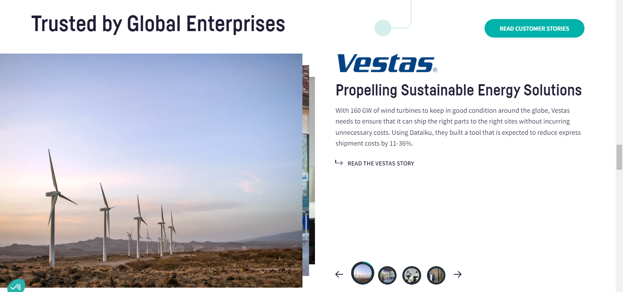

<https://www.datarobot.com/>

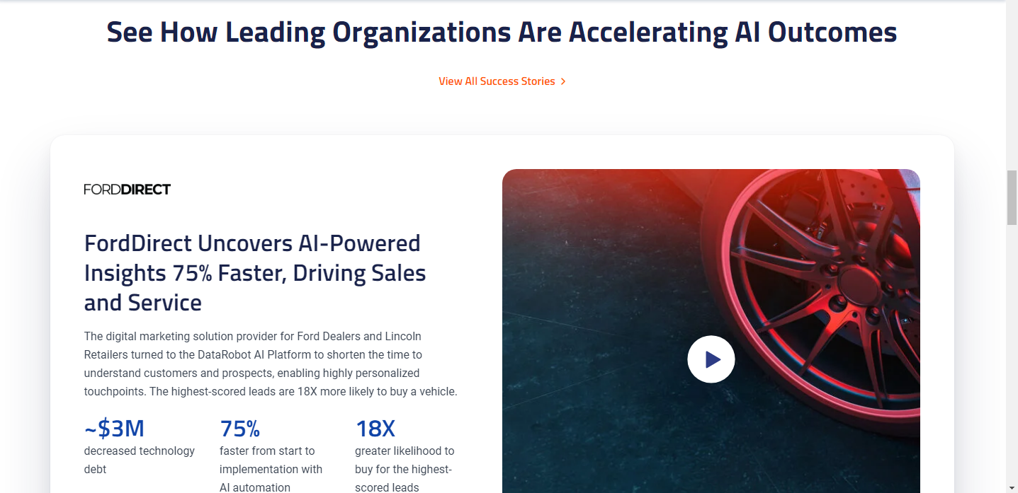

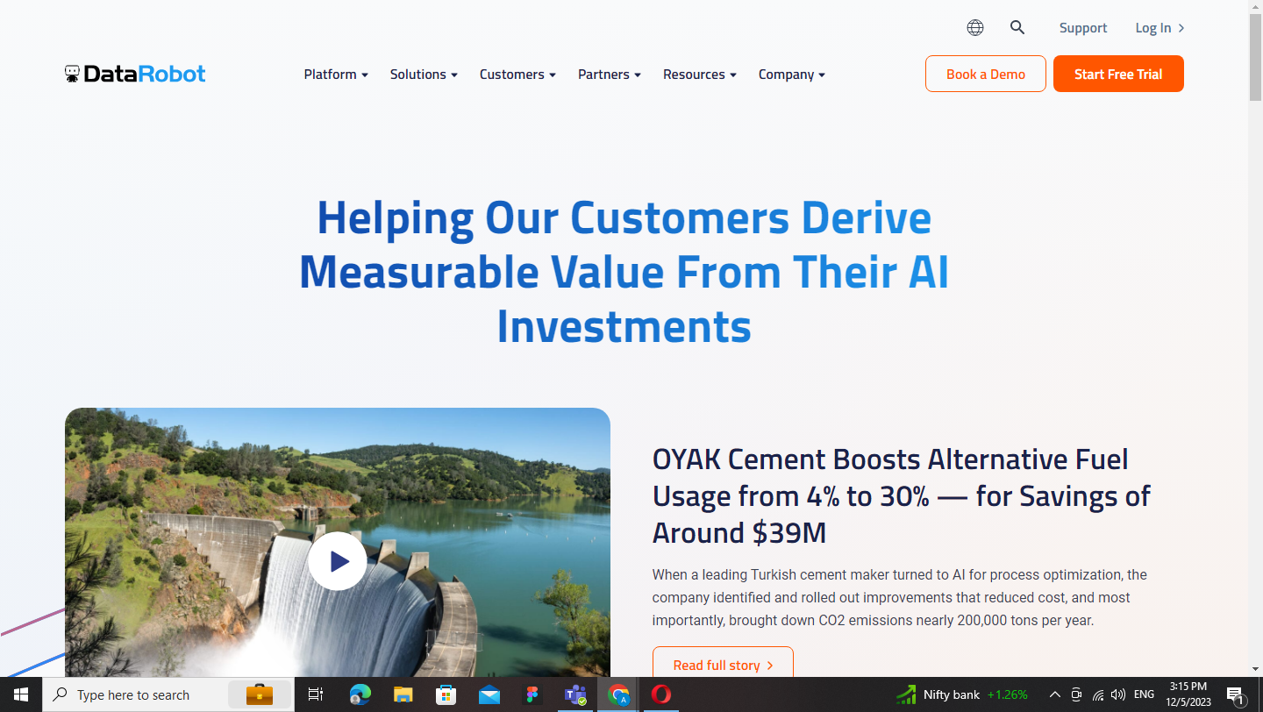

<https://www.viz.ai/>

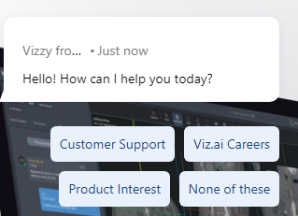

<https://c3.ai/products/c3-ai-applications/>

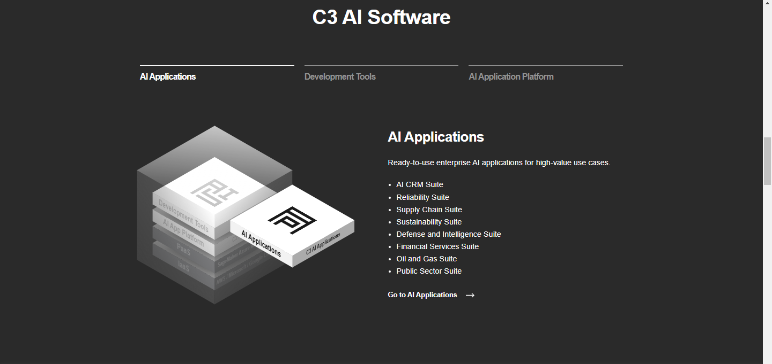

AI Consulting Services demo page

<https://aisuperior.com/services/artificial-intelligence-consulting/>

Product Suggestion

<https://www.smatbot.com/chatbot-landing?utm_source=Google&utm_medium=Search_ads&utm_campaign=AI_Services_5%2F04%2F23&utm_term=Ad%20group%201&utm_content=Ad%20group%201&gad_source=1&gclid=EAIaIQobChMIkqGLt4L4ggMV6wiDAx2JNQdJEAMYASAAEgIRofD_BwE>

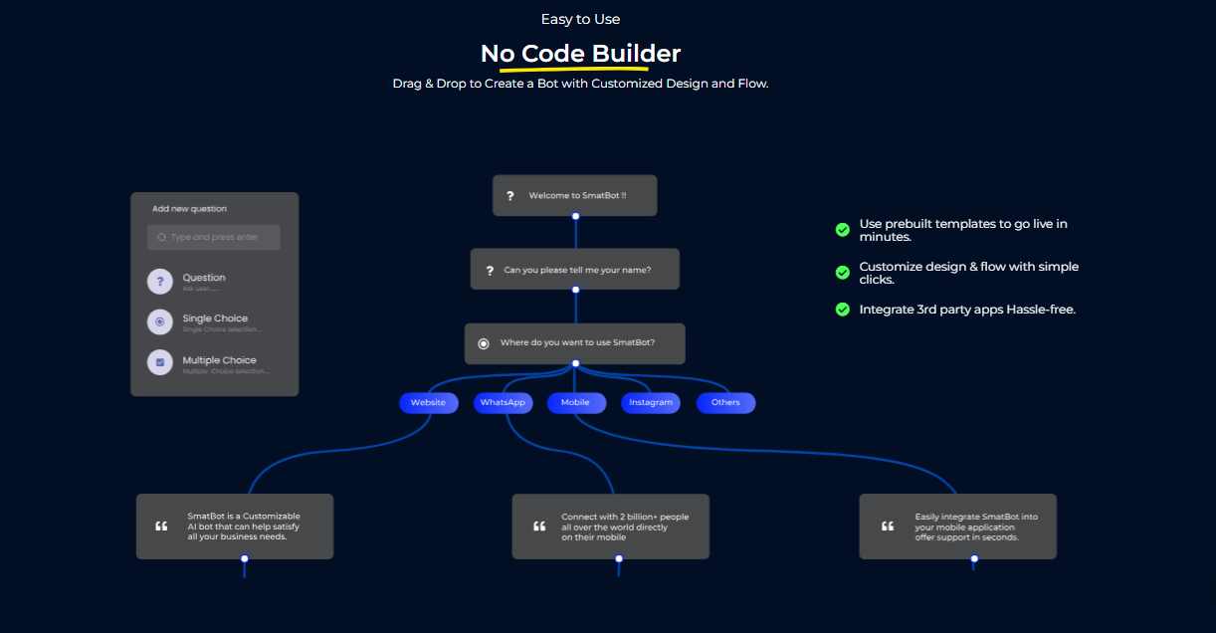

Service References

<https://allthingsai.com/>

Section 2,3,4

<https://www.matellio.com/solutions/ai-solutions-development/>

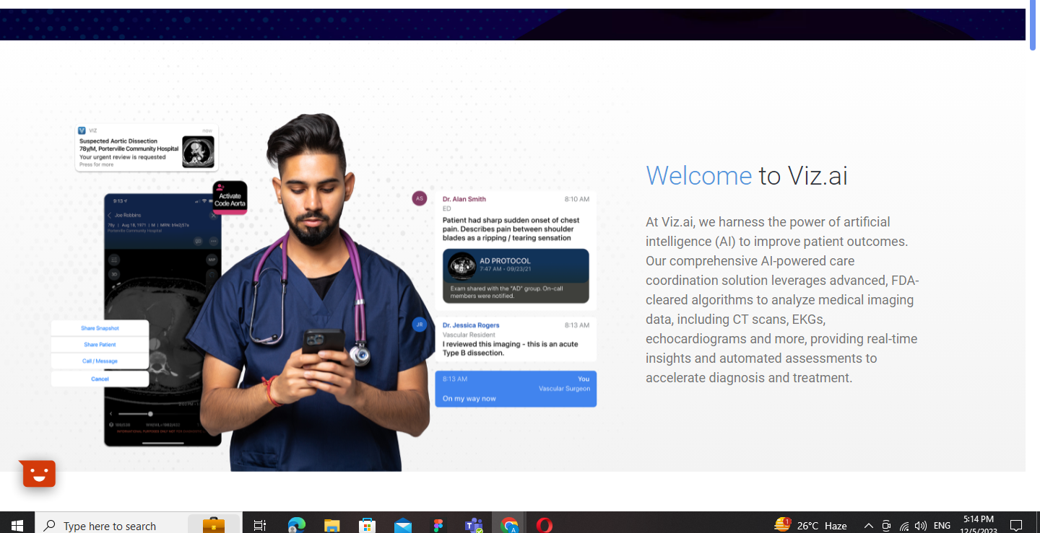

Case Studies

<https://www.codvo.ai/case-studies/improving-cyber-security-reading-by-achieving-maturity-across-cis-top-20-controls>

How can we help

<https://allthingsai.com/>